At a glance, you can see:

1. The Sales distribution of various categories relative to each other
2. Their respective Profit margins.
3. Each Category’s Sub – Category Product Sales
4. And finally, the Sales growth of the Categories over the years

So, in this article, we will learn how to make such simple visualisations in Tableau to understand our data well.  
  
Table of Contents:

1. Overview of Tableau
   1. About
   2. Prerequisites
   3. Installation
2. Getting Started
   1. Connect to Data
   2. Data Visualisations
3. Other Functionalities
   1. Filters
   2. Drill Down and Up
   3. Forecasting
   4. Trend Lines
   5. Clustering
4. Dashboard
5. Story – Bringing it all together
6. End Notes

1. Overview of Tableau

1.1 What is Tableau?

Tableau is a Data Visualisation tool that is widely used for Business Intelligence but is not limited to it. It helps create interactive graphs and charts in the form of dashboards and worksheets to gain business insights. And all of this is made possible with gestures as simple as drag and drop!

**What Products does Tableau offer?**

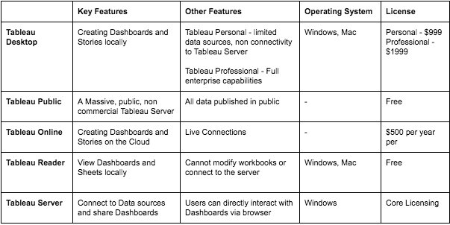

 1.2 What do you need to know before using Tableau?

A basic awareness of all the types of graphs such as bar graph, line charts, histograms etc is preferred.  
Along with that it will be beneficial if you possessed some basic understanding of database management (datatypes, joins, drill down, drill up etc) too.

1.3 Installation:

Out of the five above mentioned products, Tableau Desktop, Public and Online offers Data Visual Creation.

**Tableau Desktop**

It is available in the following three formats:

1. [Free trial for 14 days](https://www.tableau.com/products/trial)
2. If you are a student or a teacher, you get free access to the [Desktop](https://www.tableau.com/academic) for a full year.
3. [Purchase Tableau](https://buy.tableau.com/)

**Tableau Public**

[Tableau Public](https://public.tableau.com/s/download) is purely free of all costs and does not require any licence. But it comes with a limitation that all of your data and workbooks are made public to all Tableau users.

**Tableau Online**

[Tableau Online](https://sso.online.tableau.com/public/idp/SSO) is the best option for you, if you wish to make your Workbooks on the Cloud and be able to access them from anywhere.

2. Getting Started

2.1 Connect to the Data

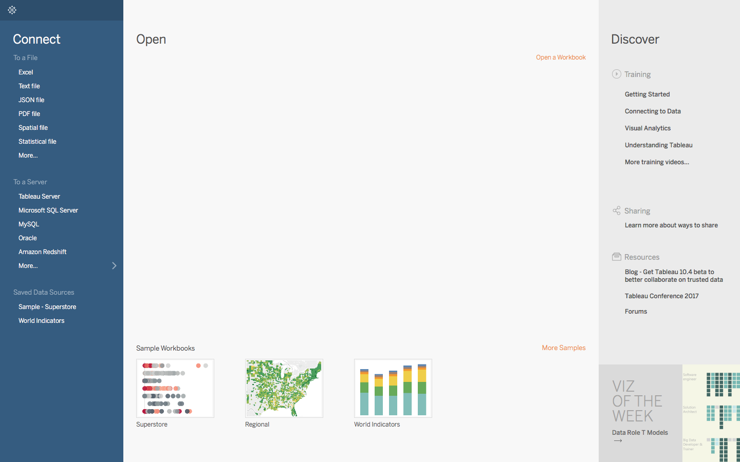

You should see a screen similar to the one above. This is where you import your data. As is visible, there are multiple formats that your data can be in. It can be in a flat file such as Excel, CSV or you can directly load it from data servers too.

You can see that Tableau itself offers some Sample Workbooks, with pre-drawn charts and graphs.

The best way to learn is to get your hands dirty. Let us start with our Data, which can be found [HERE](https://github.com/asutosh405/VisualisationUsingRandTableau/blob/master/Sample-Superstore.xls). The data is that of a United States’ Superstore which is deliberating over its expansion. It wishes to know the prospective regions of the country where it could and hence requires your help.

The first thing that you will obviously need to do is import the data onto Tableau. So quickly follow the below steps:

1. Since the data is in an Excel File, click on **Excel** and choose the Sample – Superstore.xls file to get:

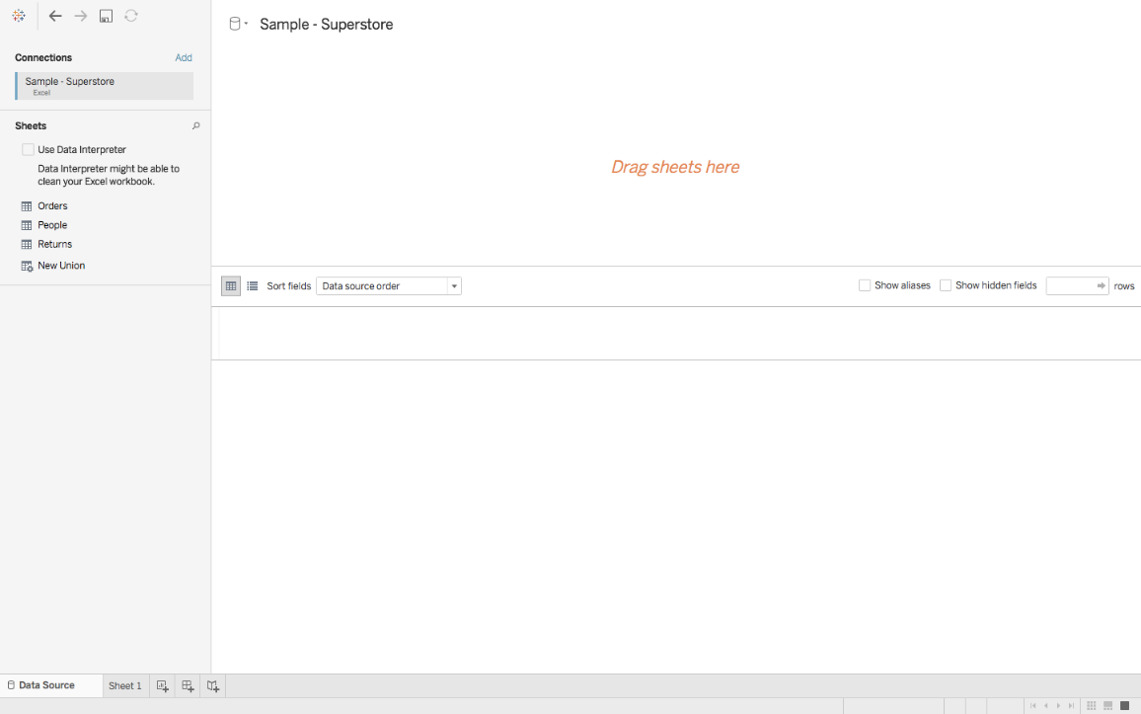

1. You can see three sheets on the screen, but we are only going to be dealing with Orders here, so go ahead and drag the same on *Drag sheets here:*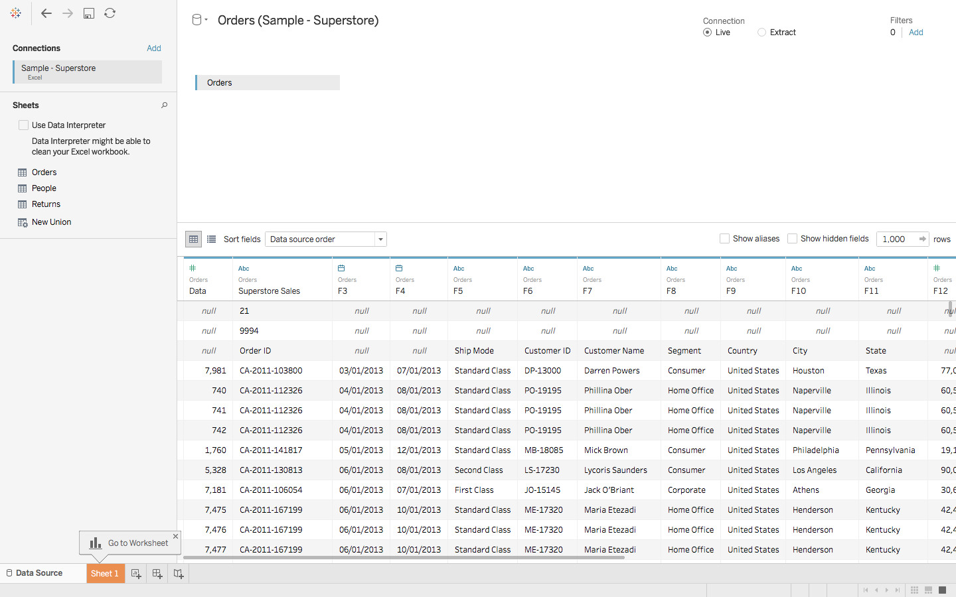

The imported data looks a bit different for the first few rows.   
Let us see how to deal with it.

**Data Interpreter**

       3. You see the option of **Use Data Interpreter**?  Click on it to get the following clean view :

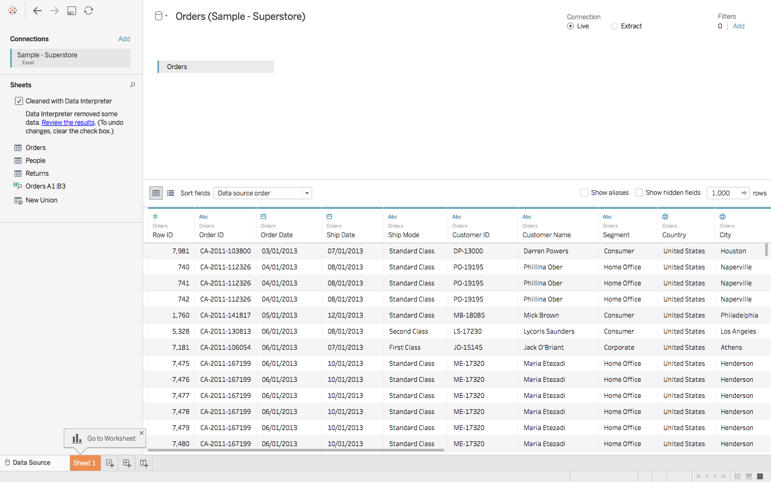

All that messy data magically disappeared!

If you open the Excel data file, you will see some metadata in it, i.e. information about data:

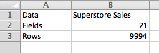

Tableau imports the entire data file as is, but anticipating such discrepancies, explicitly provides a solution in the form of a Data Interpreter. If you wish to view the exact changes that it made, click on **Review the results**, and choose the **Orders**tab in the opened Excel sheet.

As it will show, it simply removed the erroneous data.

2.2 Data Visualisations

As soon as you had imported your dataset, next to the Data Source tab near the bottom of the screen, you immediately must have seen **Go to Worksheet**. A Worksheet is where you make all of your graphs, so click on that tab to reach the following screen:

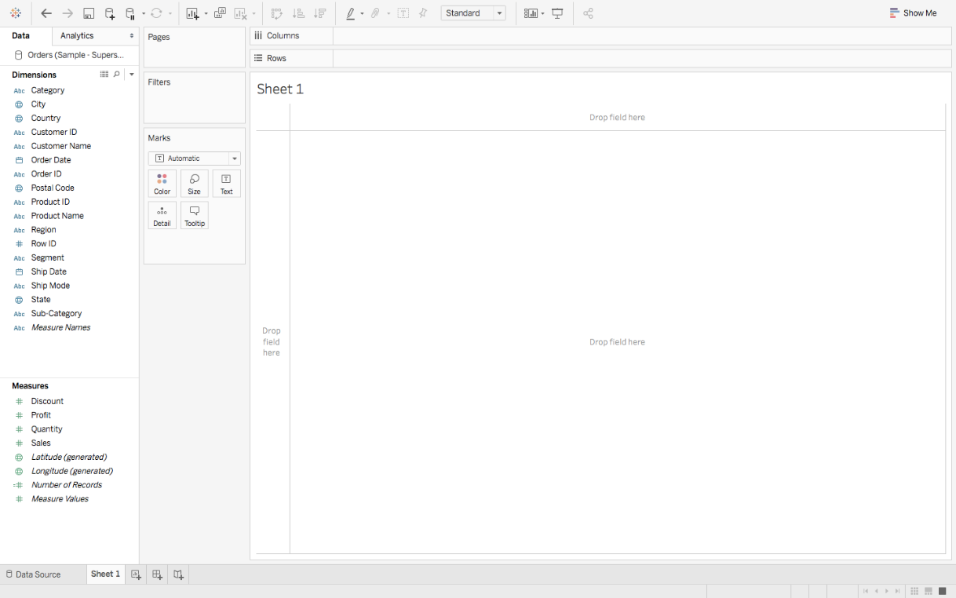

Don’t get overwhelmed by the various elements that you see here, we will cover them all one by one.

Let’s start with **Dimensions and Measures:**

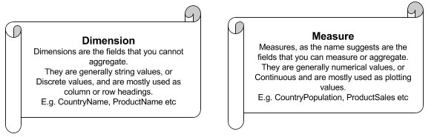

Moving onto **Shelves:**

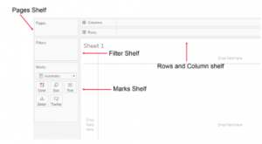

Visualisation in Tableau is possible through dragging and dropping Measures and Dimensions onto these different Shelves.

**Rows and Columns:**Represent the x and y – axis of your graphs / charts.  
**Filter:**Filters help you view a strained version of your data. For example, instead of seeing the combined Sales of all the Categories, you can look at a specific one, such as just Furniture.  
**Pages:**Pages work on the same principle as Filters, with the difference that you can actually see the changes as you shift between the Paged values. Remember that **Rosling** **chart**? You can easily make one of your own using Pages. Rosling chart in the below link:  
<https://www.ted.com/talks/hans_rosling_shows_the_best_stats_you_ve_ever_seen>

**Marks:**The Marks property is used to control the mark types of your data. You may choose to represent your data using different shapes, sizes or text.

And finally, there is **Show Me,**the brain of Tableau!

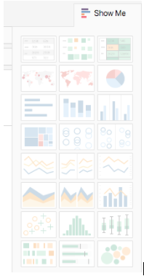

When you drag and drop fields onto the visualisation area, Tableau makes default graphs for you, as we shall see soon, but you can change these by referring to the **Show Me** option.

**Note:** Not every graph can be made with any combination of Dimensions or Measures. Each graph has its own conditions for the number and types of fields that can be used.

2.3 Various Graphs and Charts

So far, we have pretty much covered the requisite theoretical knowledge. Let us finally begin with some visualisations now.

Let us start with something simple. So, I would suggest beginning by getting an overview of the Superstore Sales and Profit Statistics. That would include the Net Sales, the Net Profit and the growth of the two measures, to name a few. Here is a gist of what we will be making:

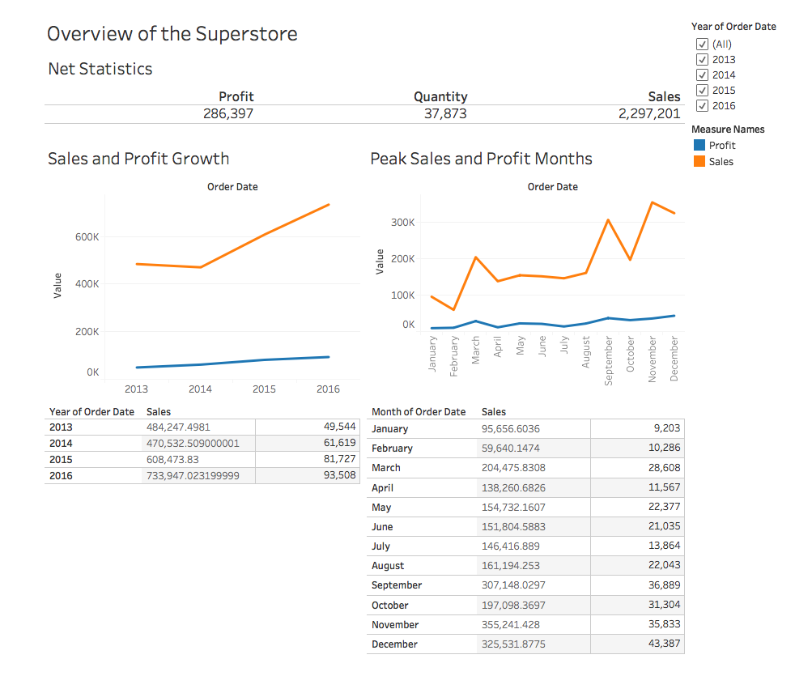

From what can be observed, the net Sales are on the rise, but the Profit is creeping up slowly. We can also quite clearly see the peak Sales Months, which could be attributed to various reasons. We can only know more as we explore more.

Before we start, there is one thing that I would like to recommend and that is **you name your Worksheets** as being done here. Since you will need to reference them back and forth throughout your work, it will be easier for you to follow.

Let’s begin with the simplest visualisation, and that is displaying the **Net Statistics** numbers. Tableau, being as smart as it is, automatically computes such values under **Measure Names** and **Measure Values**. Follow these steps to make what is called a **Text Table**:

1. Drag **Measure Names** from Dimensions onto the central empty area so that you see a Text Table.
2. **Measure Names** will be displayed automatically onto Rows, so drag it from Rows to Columns.
3. Since we don’t really need Measures like the Row ID, Discount etc, you can drag them off from below the Marks Pane, to get something like this:

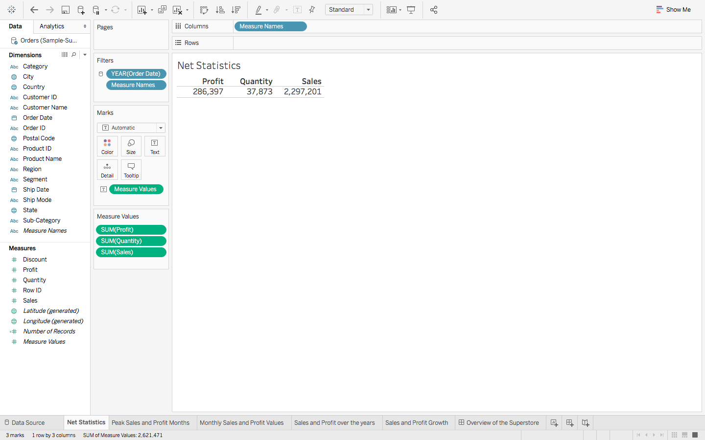

**Note:** Don’t get confused by the different colours of the fields that you see. Just remember one small trick: Blue means **Discrete** and Green, **Continuous.**

So, we have the net Sales and Profit values, let’s delve a little deeper by getting the **Sales and Profit Values over the years**. Let’s make another, but a more detailed, Text Table:

1. Drag **Order Date** from Dimensions and **Sales** from Measures to Rows.
2. Right click on the green **Sales Pill**, and select **Discrete**, in place of **Continuous,**since we want the explicit values and not the bar graphs.
3. Finally drag **Profit** on the ‘abc’ column to get. (Explore how to remove that column if you do not want profit.)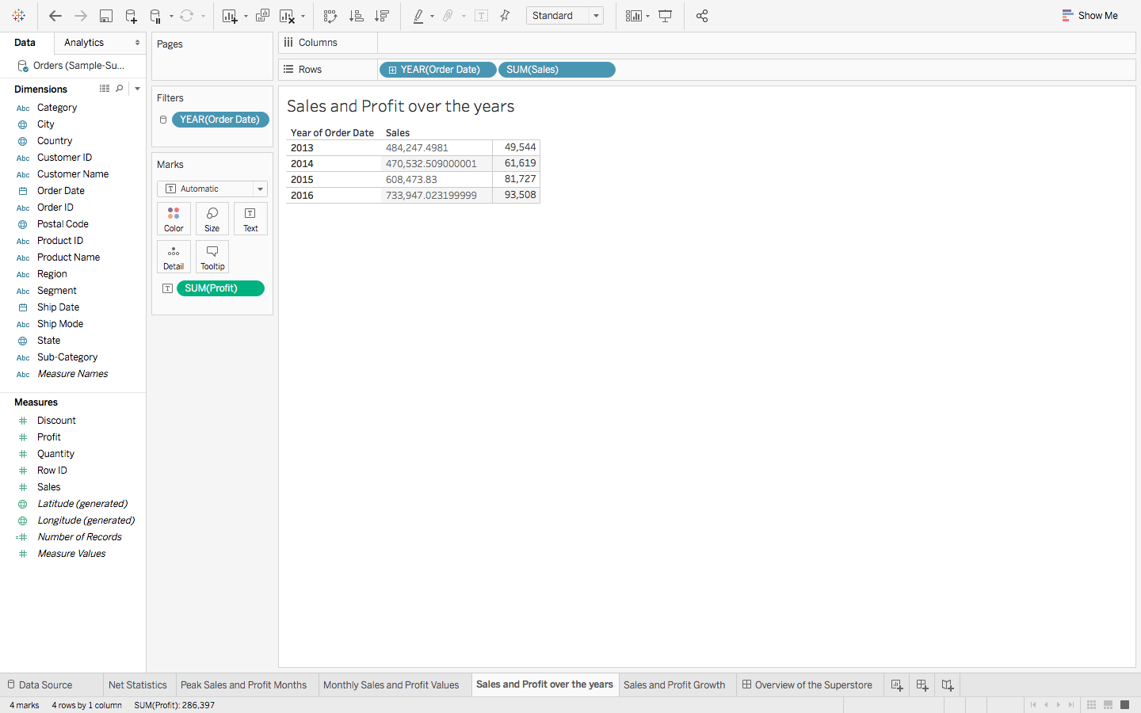
4. Do the same thing for **Monthly Sales and Profit Values**, but this time change the format of **Order Date**, from **Year to Month,**by right clicking on **Order Date**in the **Rows**, and choosing Month, to get something like this:

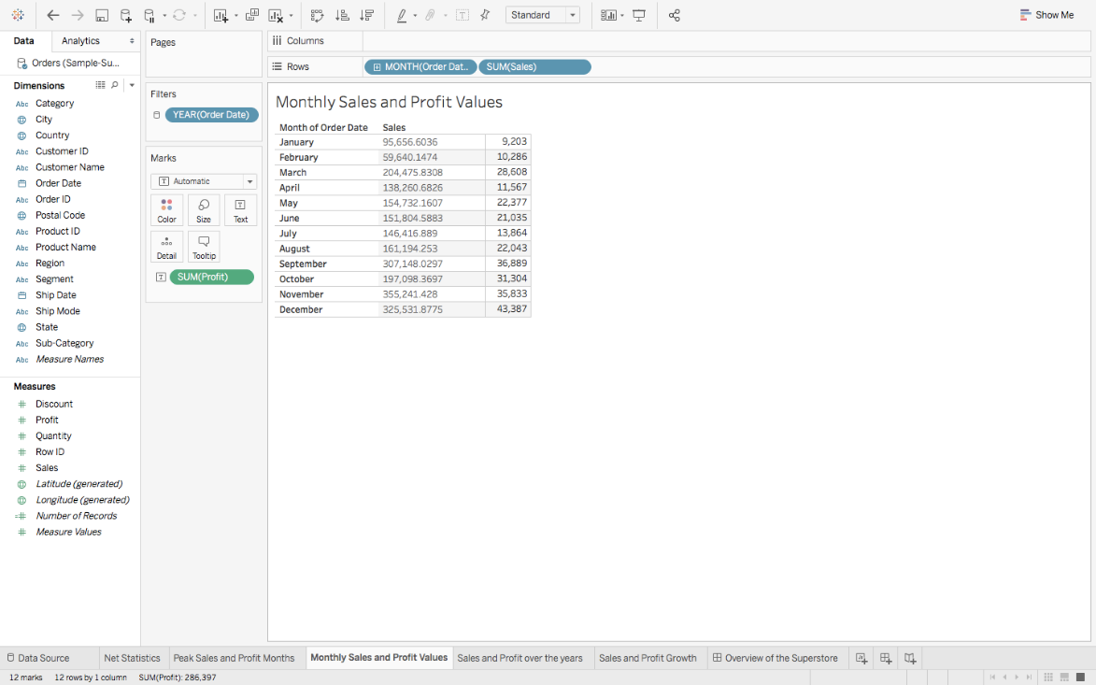

We have just covered the numeric part of the Dashboard, but that is not its selling point. It’s the **Line Charts.** Lets quickly learn how to make one:

1. To create the chart of **Sales and Profit Growth**, drag **Order Date** over the **Columns**, **Sales** over **Rows** and then **Profit** over the formed **Sales** axis – so that you see an equals sign – to get the following: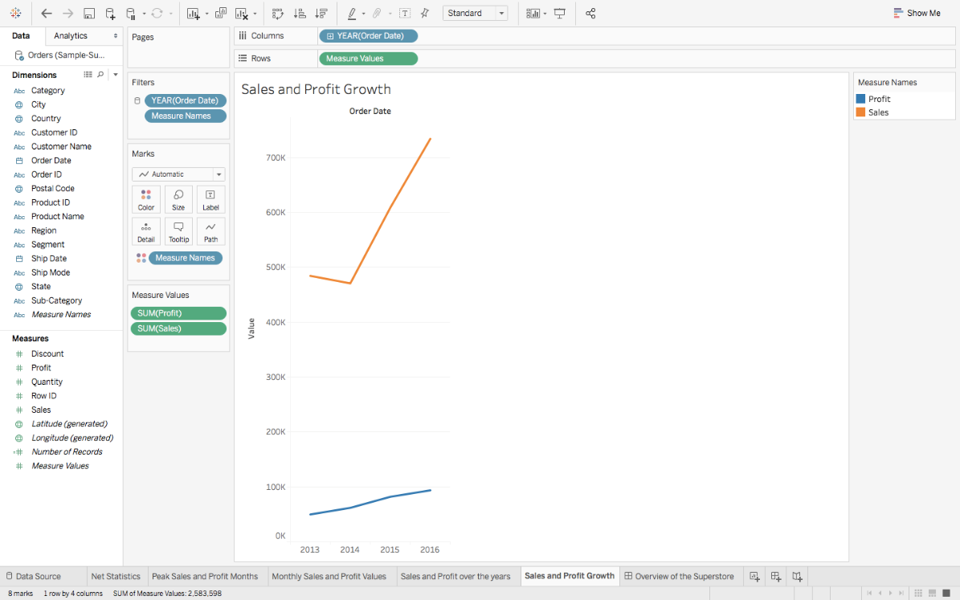
2. Repeat the same to find the **Peak Sales and Profit Months**, but again change the format of **Order Date**, from **Year to Month,**and get:

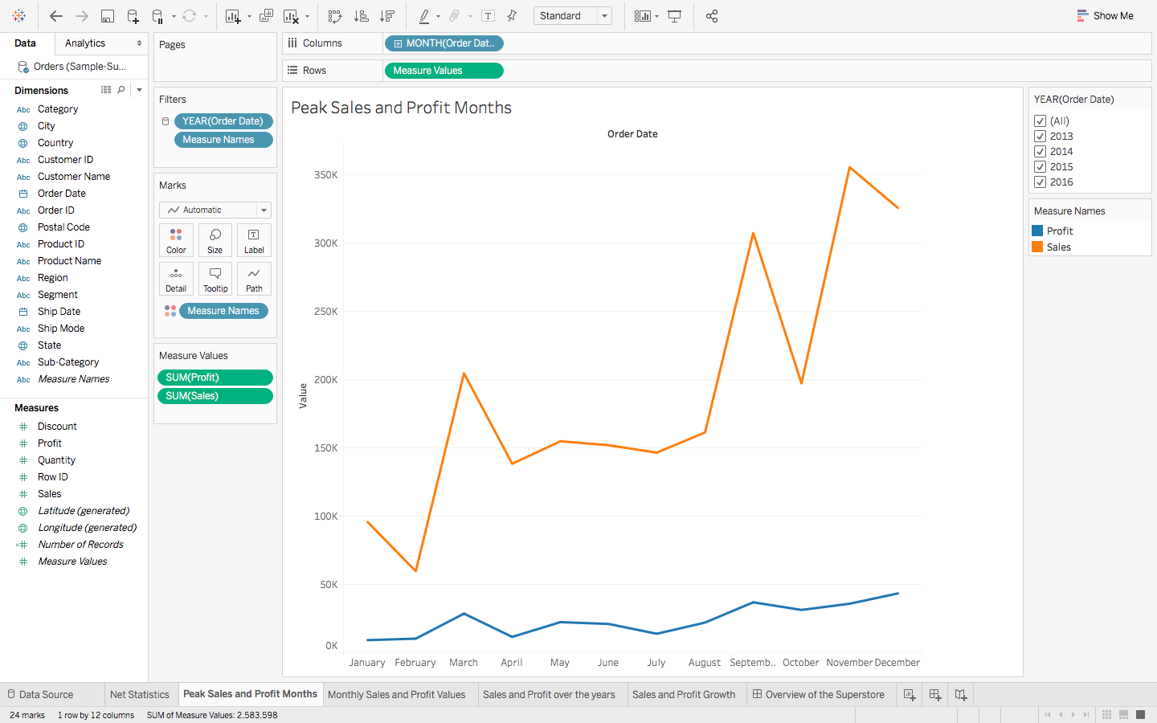

If you were to click on **Show Me**, you will see the different types of Line Charts that you can make, and if you were to hover over each of them, you will get to see their Dimension and Measure requirements too.

With the previous visualisations, we had gotten a brief overview of the Superstore. Let’s dig a little deeper now. The next thing that I can think of exploring is the demographic of the Sales and Profit. What are the States that have the highest Sales Revenue, which ones are generating the maximum Profits:

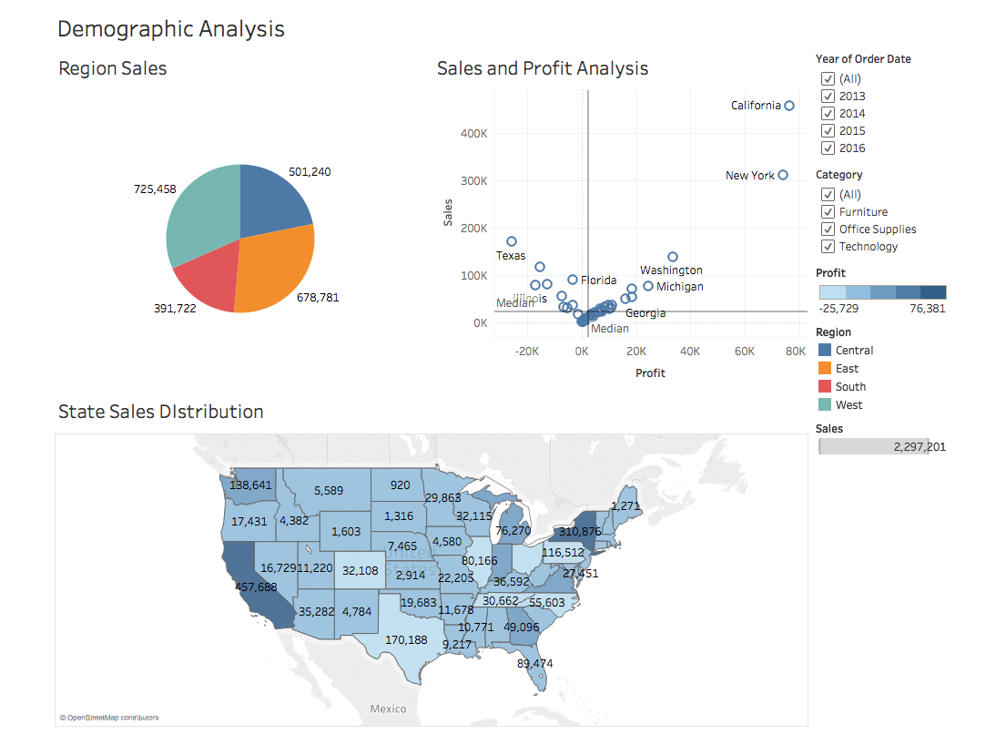

Before discussing the inferences, let’s first create the **Pie Chart** of **Region Sales:**

1. Drag **Regions** onto Rows and **Sales** onto Columns.
2. Go to **Show Me**, and select the **Pie Chart**.
3. And finally drag **Sales** over the **Label** in the **Marks Pane** to get:

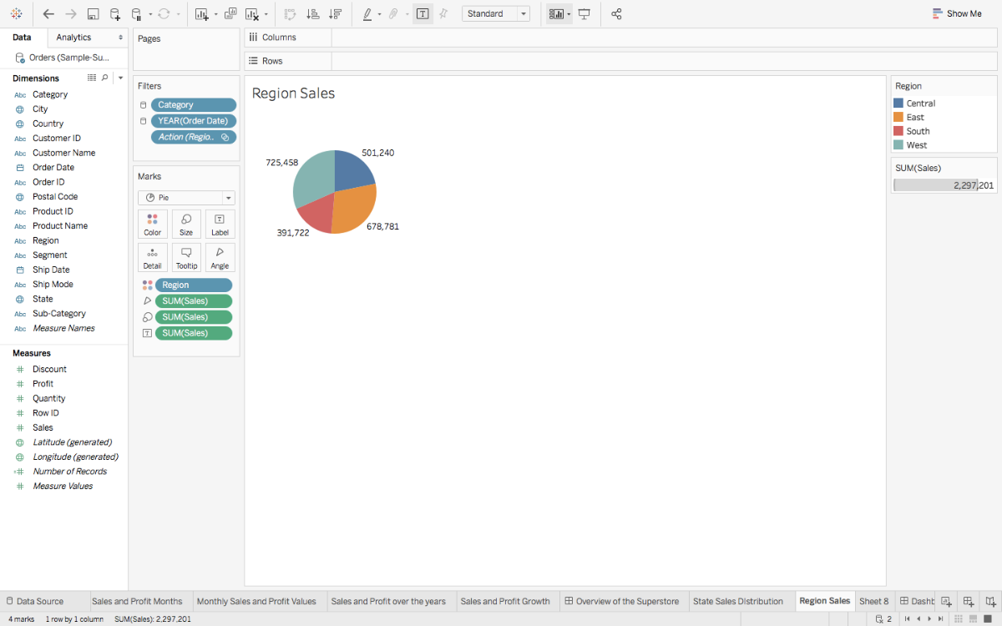

From the visual it’s pretty evident that the two opposite ends, East and West are leading in the Sales game. Let’s dissect this a bit more.

**Note:** Whenever you have some geographical data, it is always advisable to plot and see it on a Map to gain better insights.

So, we are now going to make the **Map Chart** of **State Sales Distribution**:

1. Since its the States that we wish to analyse, drag **States**onto the empty area, so that you automatically see a Map, with small Circles. Follow this step by dragging **Profits**next. You will notice the size of these circles changing to represent the varying values of Profits. This is called a **Symbol Map**. But we are going to convert this into a **Filled** one, by going to Show Me, and selecting the **Filled Map.**
2. Drag **Profits** again, but this time onto **Label** in the **Marks Pane**, to view the Profit Values mapped as well, like so:

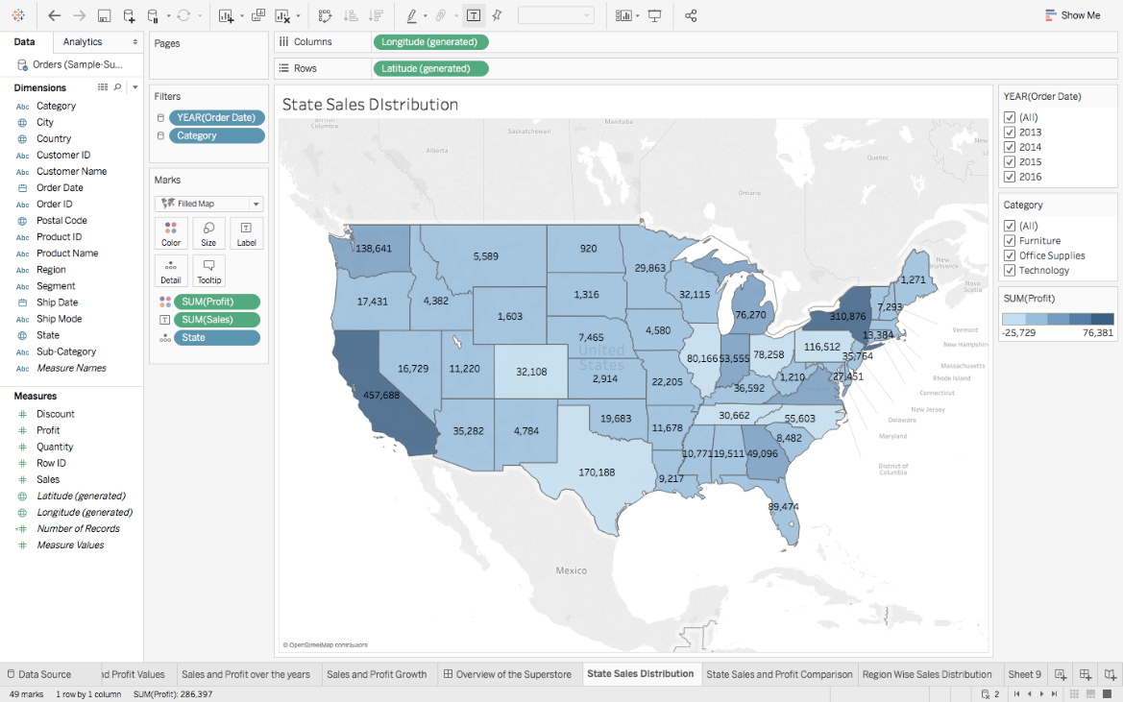

California and New York are the top most sellers from West and East region, but unfortunately there are other States such as Texas, Colorado which even after having good Sales, have negative Profits! This is certainly not good news for the Superstore. You can perceive a good analysis for the other States as well.

And lastly, here are the steps for making the **Scatter Plot**of **Sales and Profit Analysis:**

1. Drag **Sales** onto Rows, and **Profit** onto Columns. You will see one tiny circle, which actually represents the Total Sales and Profit Values.
2. To get more information, drag **States** onto the graph created, so that these circles / bubbles scatter to represent the individual States.
3. To better understand the central tendency of the data, we have also added a **Median axis** as Reference Line. This can be easily done by right clicking on the **Sales / Profit Axis – > Adding Reference Line**and choosing Median over the default Average Reference.
4. Finally, for some more insight, drag **States**again, but this time onto **Label** in the Marks Pane, and get:

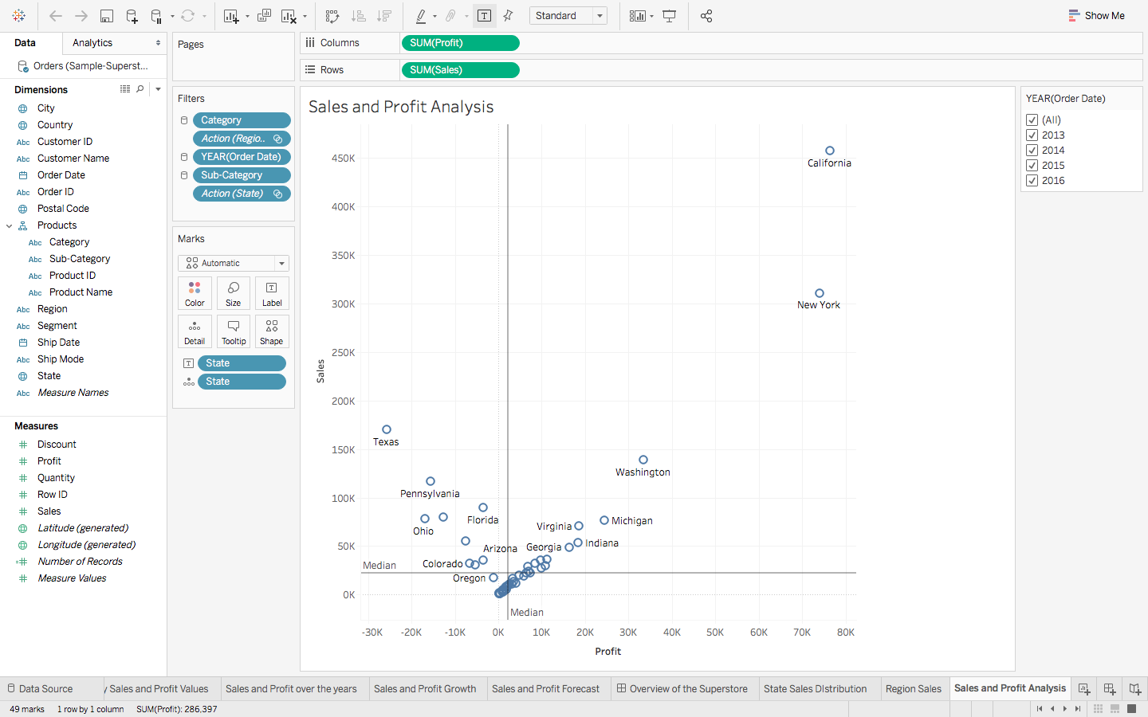

The findings from the **Map chart** become more prominent with the following **Scatter plot** inferences:

* The states in the top right, with high Sales and high Profits mean good business for the organisation.
* States with positive Sales and Profits, but near the two respective axis are the ones where there is some scope of improvement.
* Whereas the states that belong to the 2nd or 3rd quarter are the ones which are not generating much revenue.

One of the great things about Tableau is that it lets you interact with the visuals. Have a look at an example:

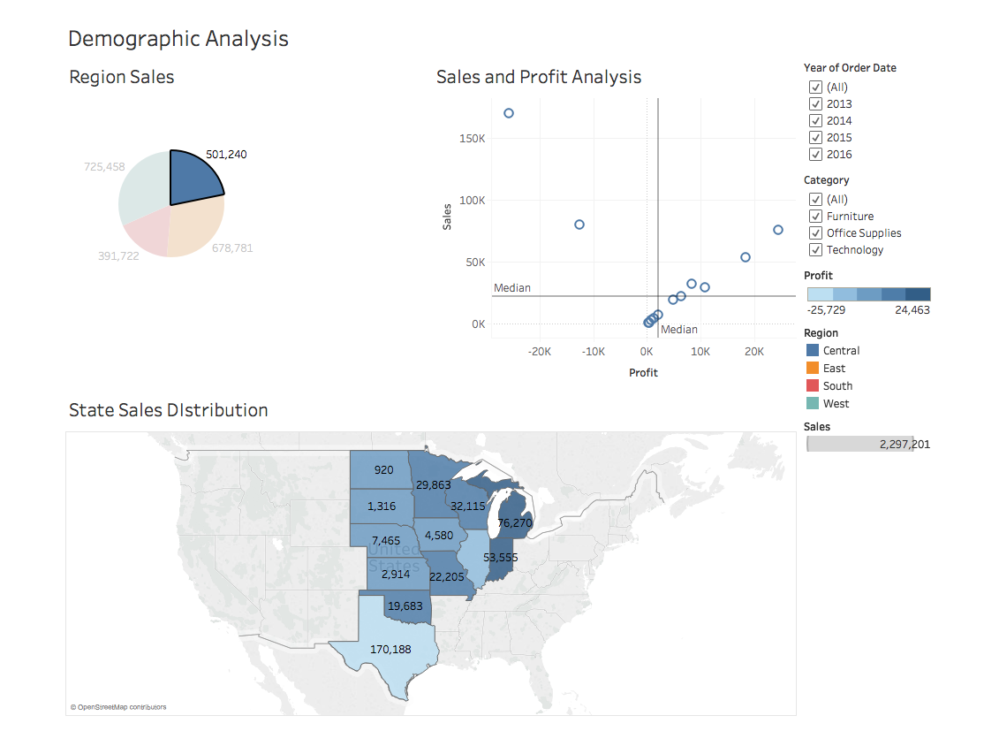

When we clicked on the Central Region, it highlighted and showed the Central States of US, along with their respective Sales and Profit scatter. Here we used the chart as a Filter itself which is a feature of a Dashboard. We shall learn how to make one at a later stage.

There is one pretty important analysis that we have yet to touch, and that is Product Statistics. High Sales could be easily attributed to the high cost of the products being sold. Also, when you are considering expansion, you will want to know the Sales distribution of the Products too:

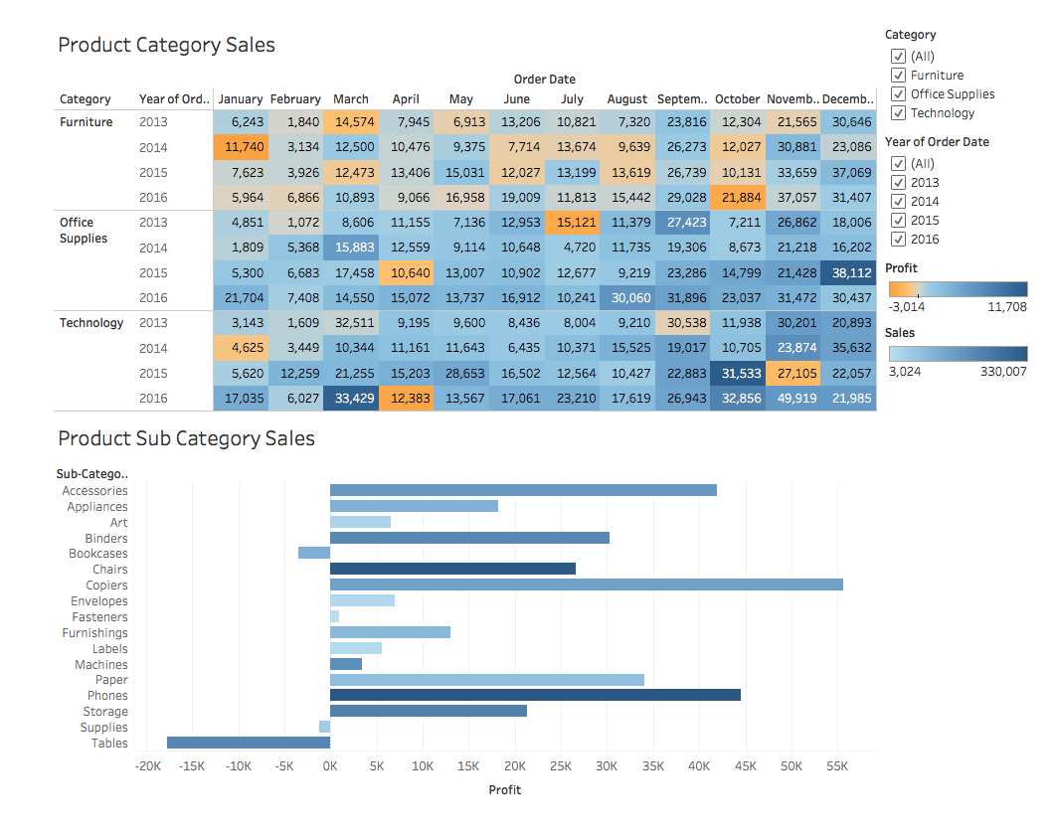

Here we have visualised not just the Sales but also the Profits.

Its quite surprising to see Categories that have high Sales, generating negative profits, like Technology in November 2015, or Furniture in October 2016 and this is inferred from the first chart, which is also called a **Highlight Table**. As the name suggests, it highlights the relative proportion of the Measure Values of our data. So let’s learn how to make one:

1. Drag **Category** and **Order Date (Year)** in Rows.
2. Drag **Order Date (Month)** over Columns, and **Sales** over the empty ‘abc’ fields
3. Select **Highlight Table** from Show Me, and drag **Order Date (Year)** back to Rows, in case it got re-shuffled.
4. Finally drag **Profits** over **Colour** in the **Marks Pane,**to get**:**

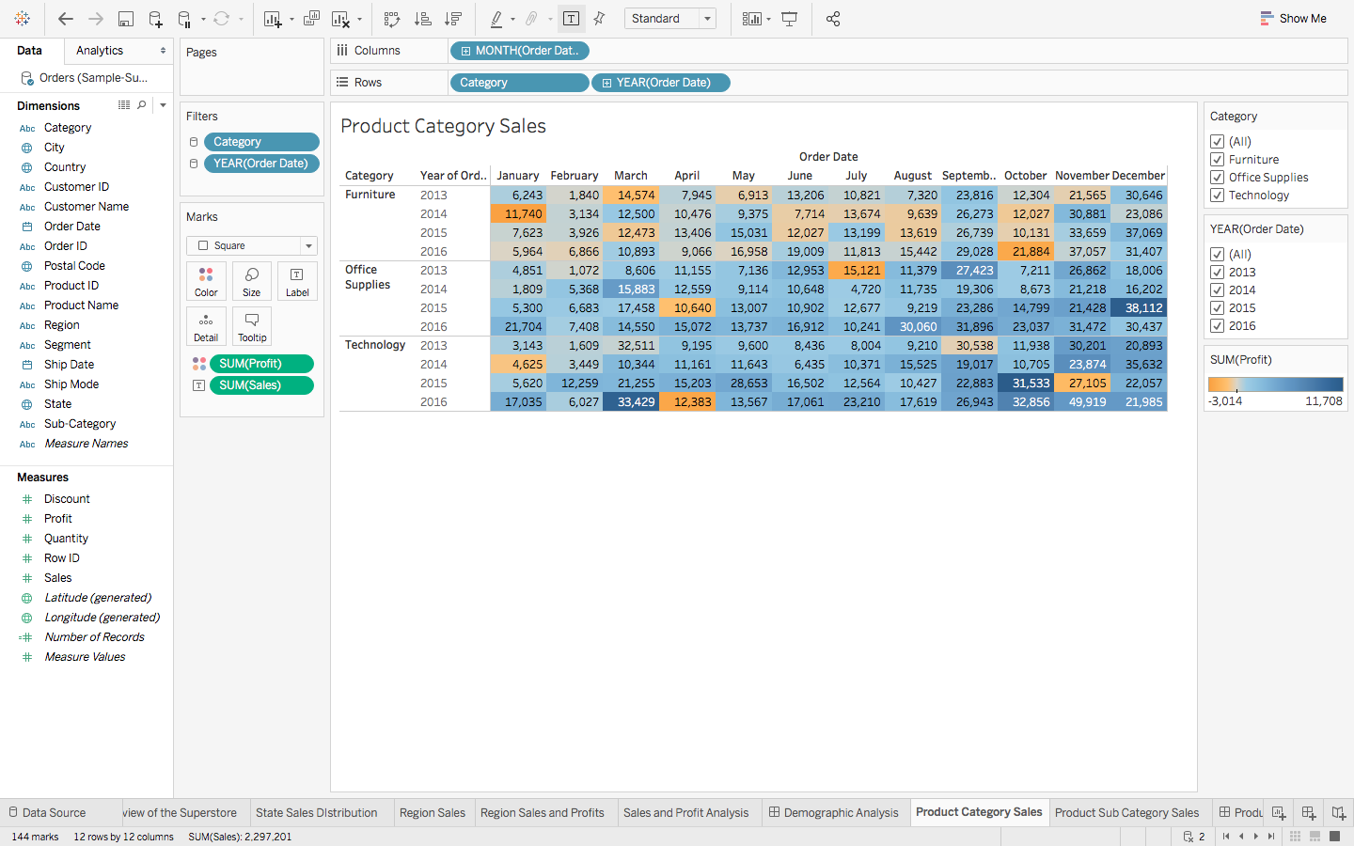

The **Product Sub Category Sales**is a **Bar Chart**, which is also quite easy to make:

1. Just drag **Sub – Category** over to the Rows
2. Drag **Profit** onto the Columns.
3. Go to Show Me and choose the **Horizontal Bars**
4. For some customisation, drag **Sales** over **Colour** in the Marks Pane to attain this final visualisation:

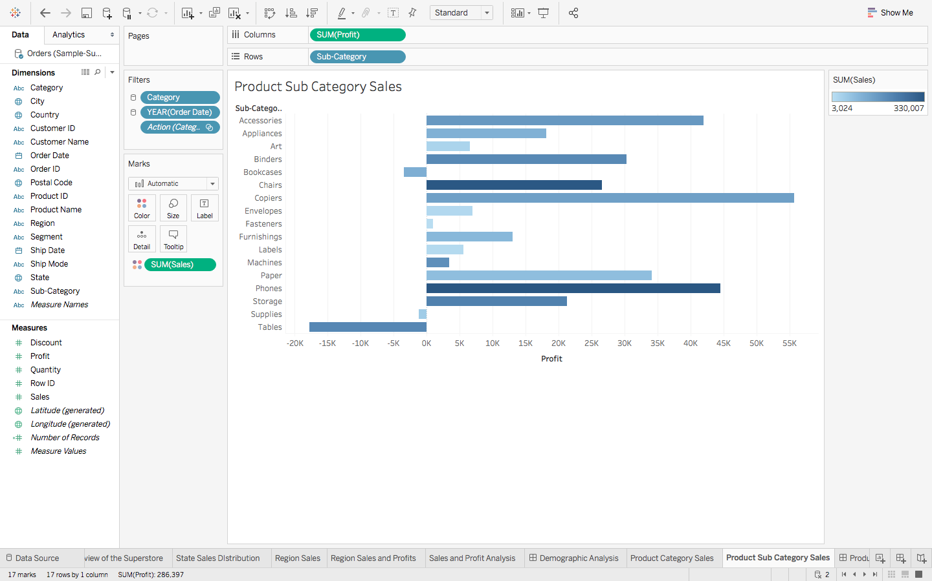

From the above graph, we are getting a good idea of the Net Sales and Profit margins of the various products. Notice that even though Tables’ Sales are quite high on the scale, it’s the only product with the least profit.

Now, just like before, consider an interaction with the visualisation:

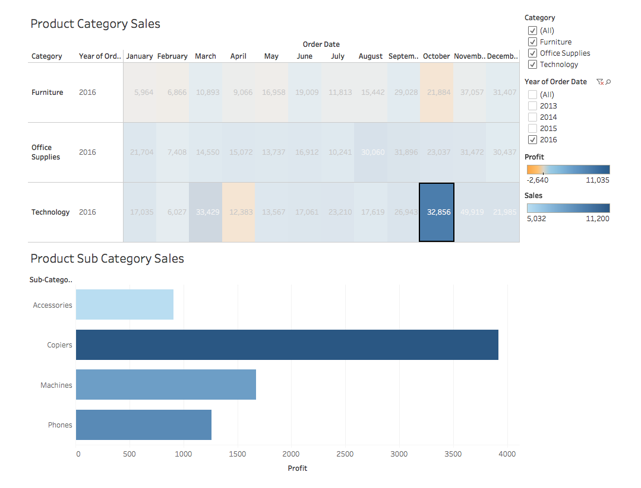

We are now able to view each Category’s Products’ Sales and Profits, at a low level granularity of Year and Month!

 3. Other Functionalities  
3.1 Filters

Till now we have only made simple charts, that actually provide cumulative data, that is combined data over the lifetime of the Superstore. To look at Sales of a particular Year, a Month, for a certain Product, or to basically view the distinct aspects of the data, **Filters** are the way to go.

Let’s head back to the first ever Chart that we had made, of **Peak Sales and Profit Months:**

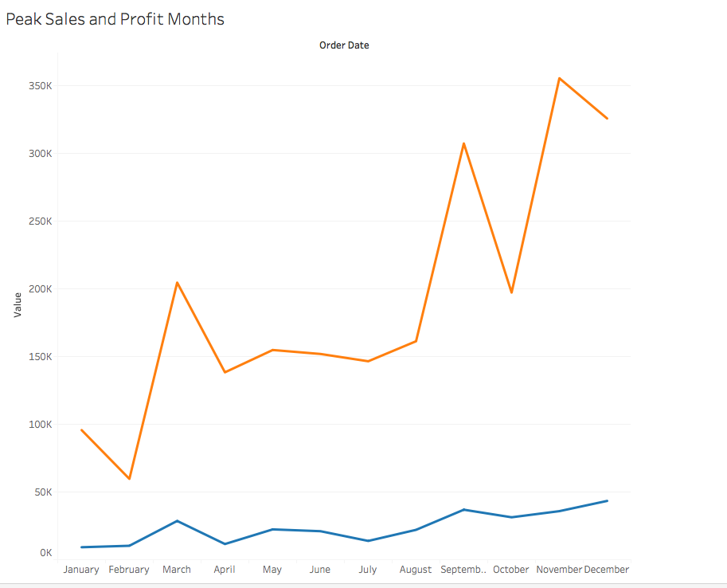

The visual here is an accumulation of all 4 years of data, for all Regions, States, Categories and Sub Categories.

The steps of turning any Dimension into a Filter are the same. Let’s first experiment with the Order Date (formatted to Year) :

1. Drag the Dimension to the **Filters’ Shelf,**to see the following pop up. Here we will be choosing Years:

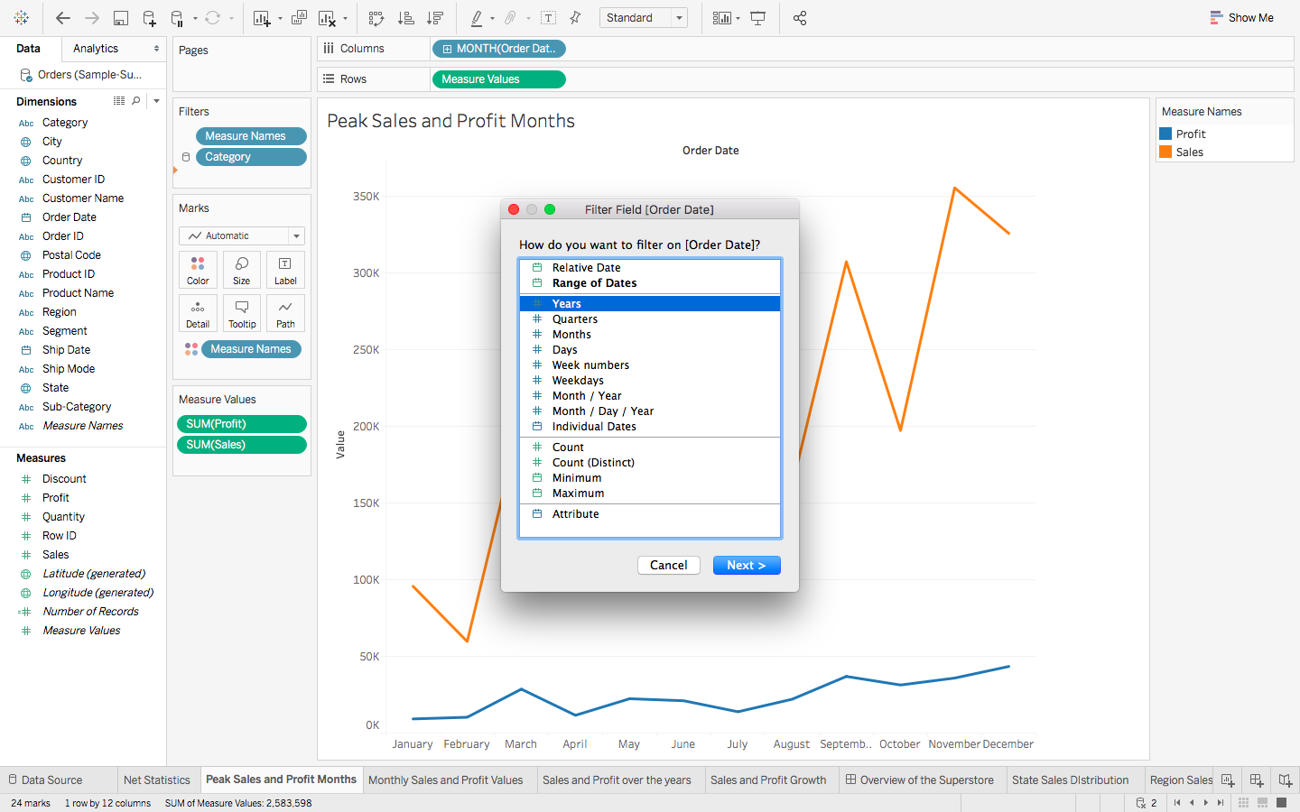

1. Choose the values that you want to be a part of your Filter: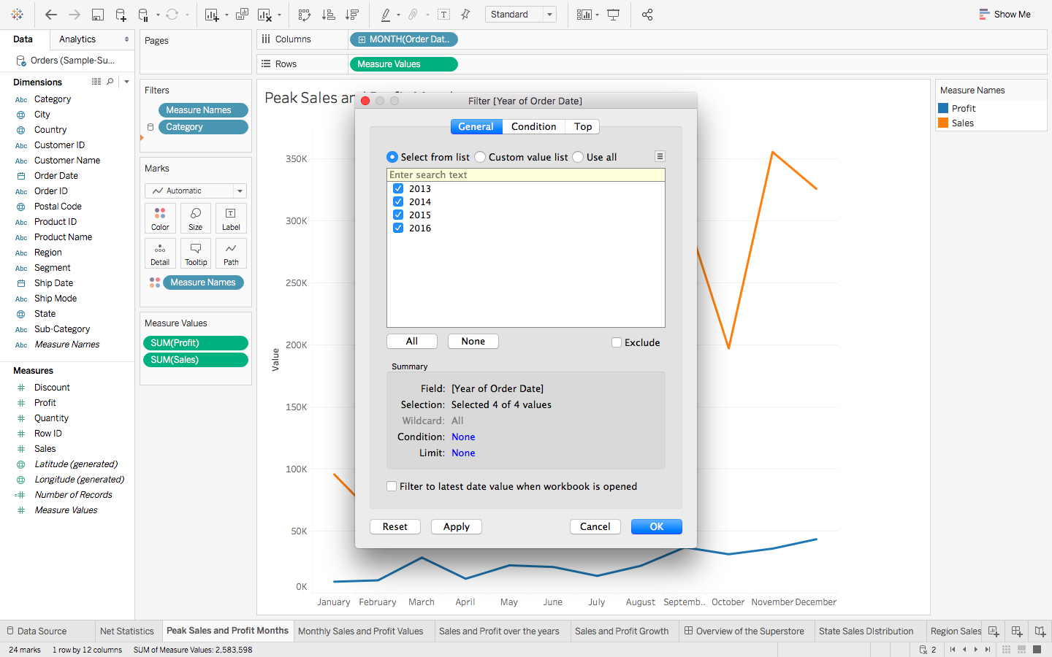
2. Right click on the newly generated Filter, and then choose Show Filter: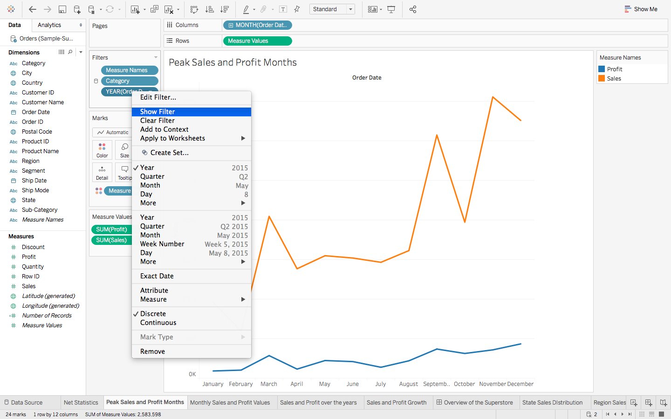
3. You can also change the format of your Filter, for example whether you wish for a Dropdown list, a Slider, a Single Value List, etc: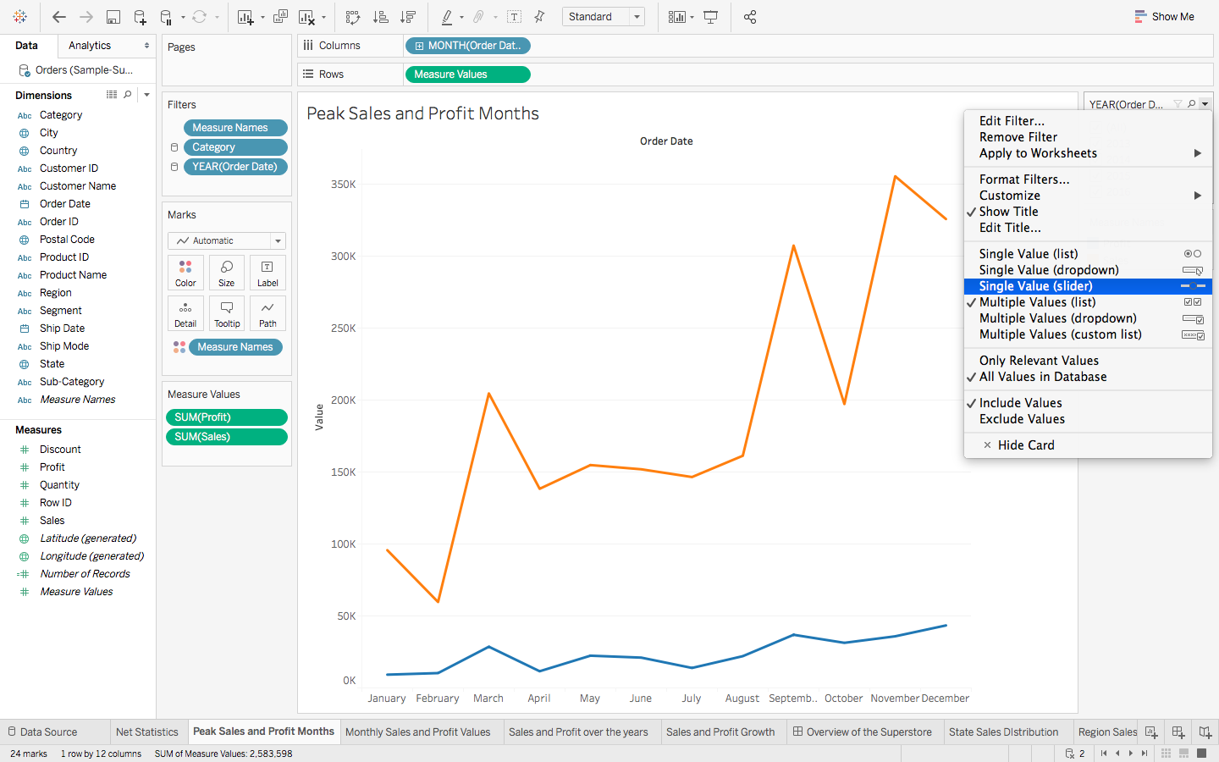
4. If you feel that some of your filters can be applied to other sheets as well, then rather than repeating the steps, you can simply **Apply the Filter** to all other relevant Worksheets:

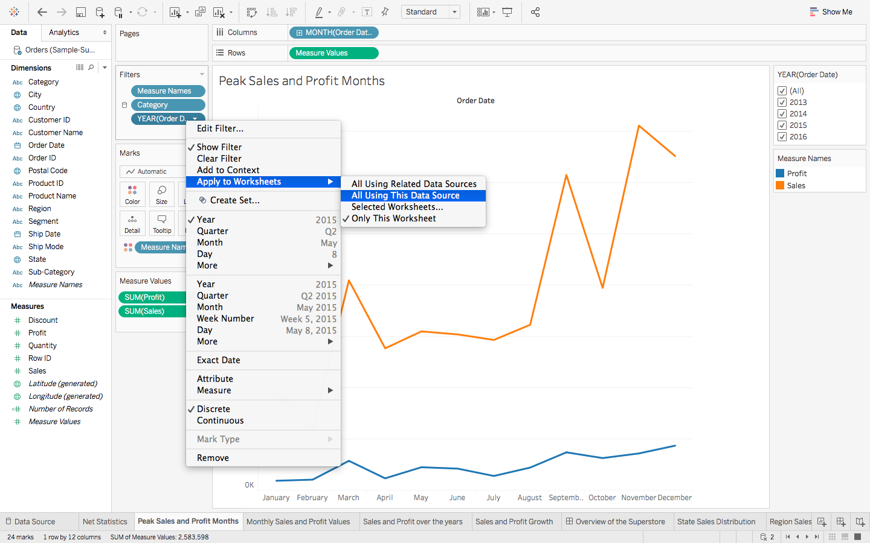

 3.2 Drill Down and Drill Up

We have Category as the main Field, divided into Sub – Category, which is further distinguished into the various Product IDs and their corresponding Product Names.

This concept of breaking down our data to reach the absolute depth is called **Drilling Down:**

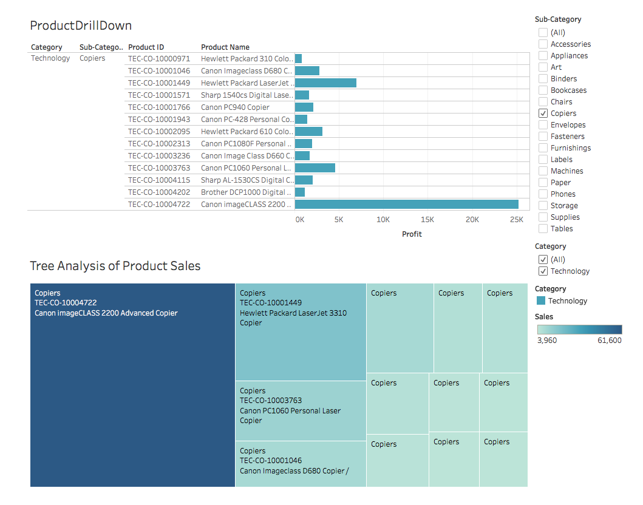

Similarly, you can drill down from **Order Date** to Order ID to Ship Date to **Ship Mode**. This is also referred to as making an **Hierarchy** of data.

Let’s consider the **ProductDrillDown** first, which is really a **Bar Graph**:

1. First you need to group the Dimensions you want in a single Hierarchy. So, drag **Sub – Category** from Dimensions **on top of Category**in the Dimensions itself, and change the Name of the hierarchy to **Product.**
2. Now drag **Product ID** and **Product Name** over this **Product** Hierarchy
3. Do the same for Order Hierarchy to get:

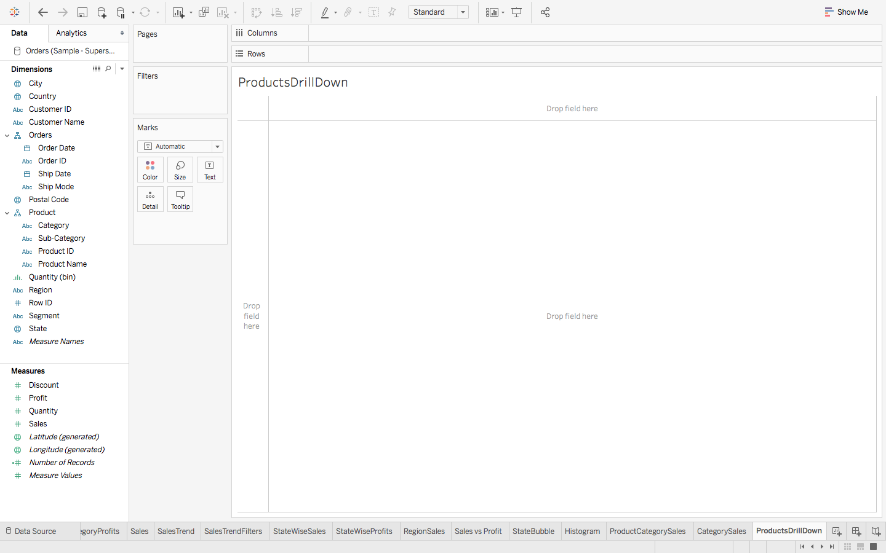

       4. To finally plot your data, drag the **Product Hierarchy** onto Rows and **Sales**onto Columns, and get:

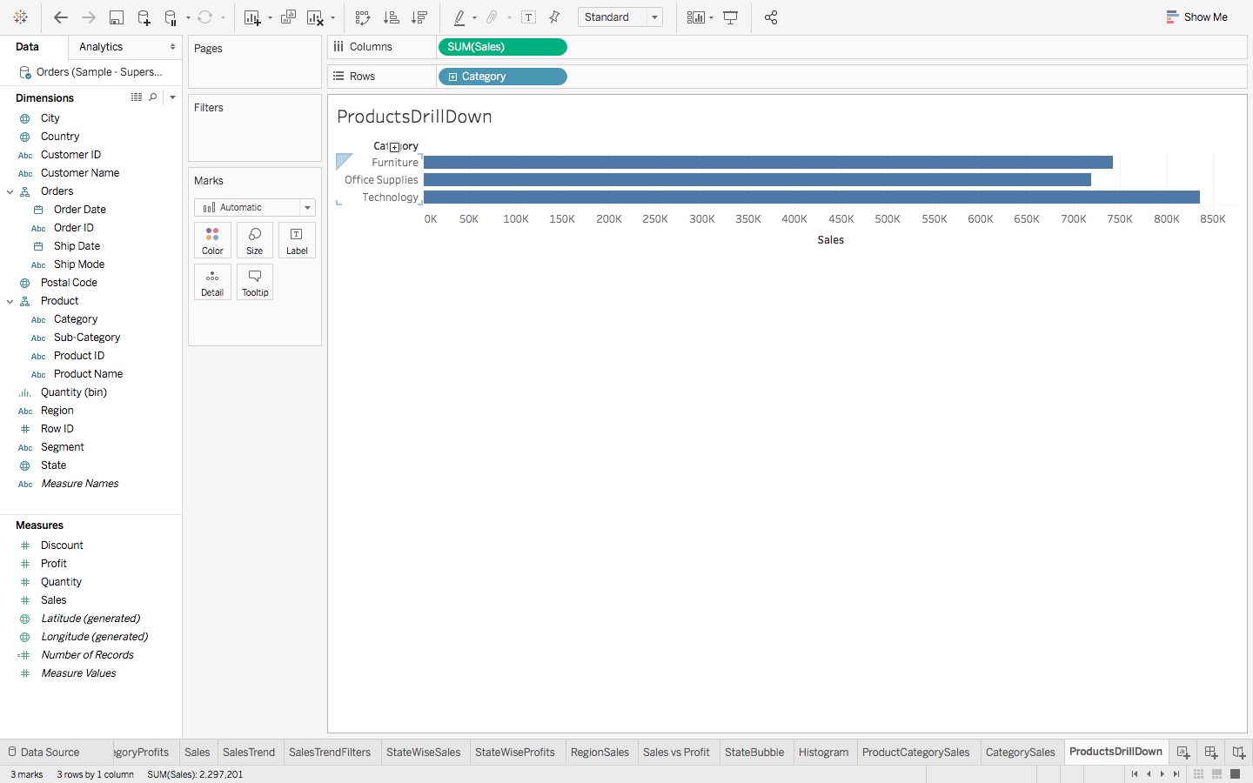

This was just a simple Bar Graph, but if you hover over the **Category** axis, you will see a small plus sign. Click on it to get a granulated version of your data. Do the same for the other generated axis as well to get to the absolute depth.

The**Tree Analysis of Product Sales** is a **Tree Map,**which is a great way of representing Drilled Down data, and is quite easy to make:

5. Following the drill down from **Step 4**, simply go to Show Me and select the **Tree Map**chart, to get the following**:**

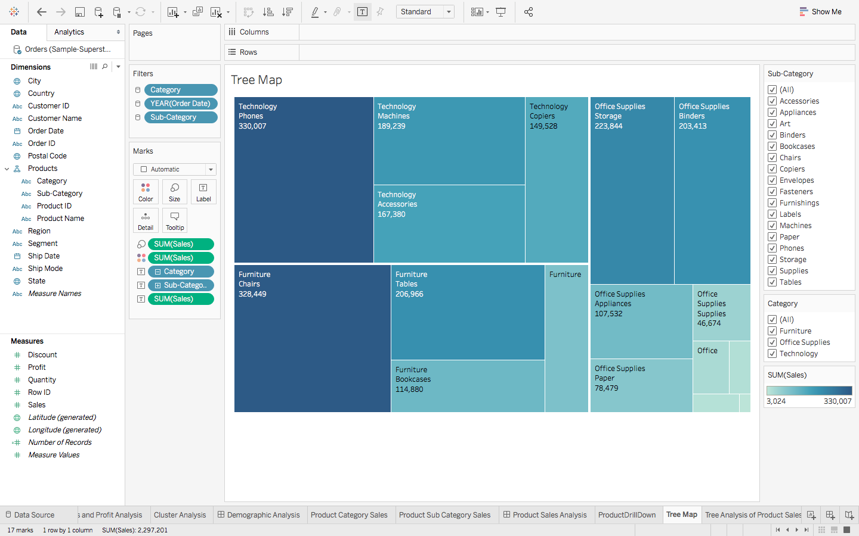

So far you have analysed the present scenario, but for expansion consideration, let’s try and analyse the future too.

With the following Dashboard, you can not only see the **Trends over the Sales** Months, but also a **Forecast over the Years** too. And both of them tell a different story altogether:

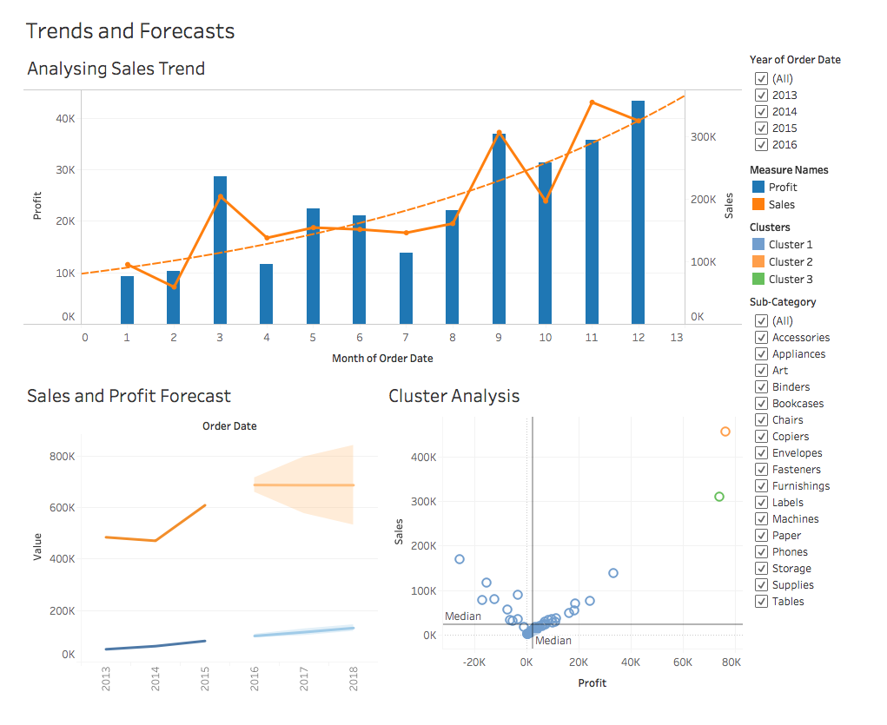Although the Sales of the Superstore are increasing over the months of a Year, the future in general looks a bit bleak. The sales seem to become constant for the next 3 years, but fortunately for the Superstore, the Profit is increasing steadily. Let’s get to making the above now.

3.3 Trend Line

Traverse back to the **Peak Sales and Profit Month** Chart and follow these steps to make a Trend Line of your own:

1. Go to **Show Me** and choose the **Dual Combination** chart, to get this chart:

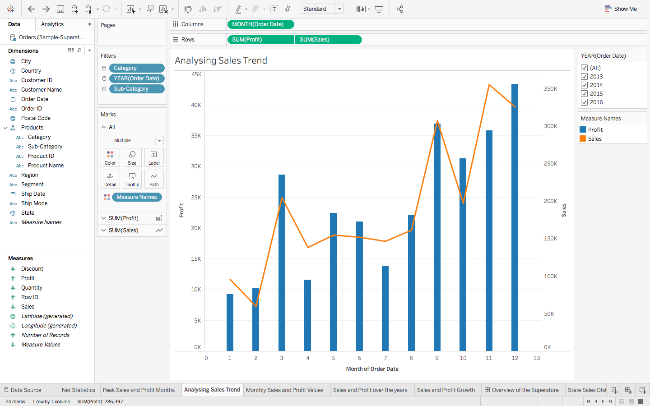

       2. To get the **Trend Line**, go to **Analytics**, and simply drag **Trend Line**over the chart, to get:

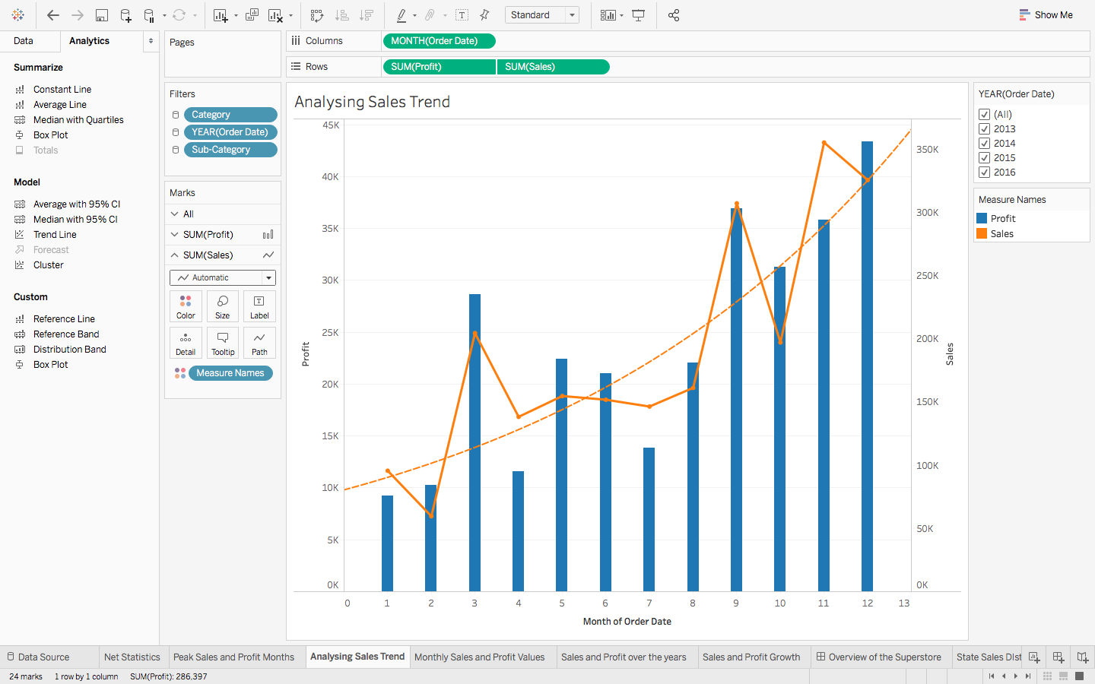

3.4 Forecasting

For **forecasting**, we are going to deal with the **Sales and Profit Growth** chart. The construction is similar to that of Trend Lines, but with a small change. The steps are:

1. Drag **Forecast**over the chart.
2. You can also change the time frame of the Forecast, by right clicking on the Forecast Area and opting for **Forecast Options,**after which you can make your customisations:

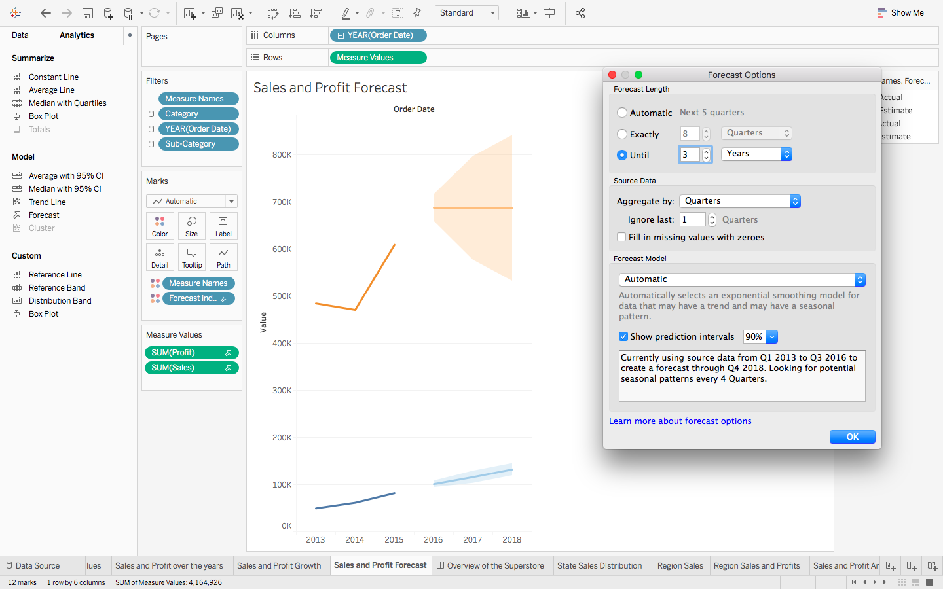

 3.5 Clusters

Let’s head back to the **Sales and Profit Analysis**chart that we had made. Remember the detailed inference that we had generated from it? We are just going to make that a bit more prominent now, using **Clusters.**To make them:

1. Go to **Analytics** and choose **Clusters.**
2. You can format the Cluster formation as per your wishes. Here we are clustering based on the **Sum of Sales and Profit**, choosing the **number of clusters to be 4**:

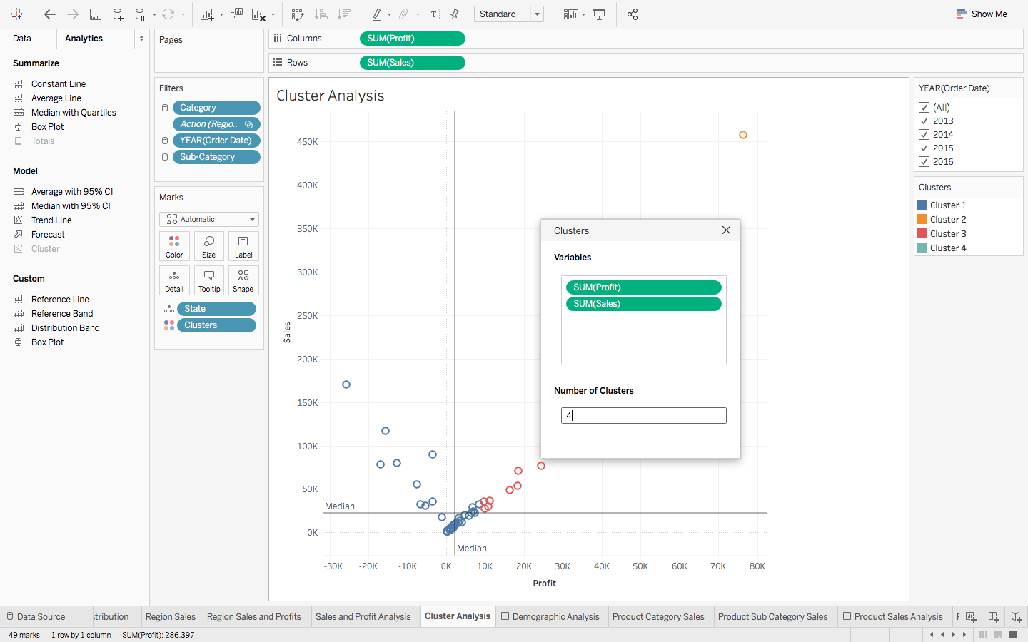

1. To view the Cluster information, right click on **Clusters** in the **Marks** Pane, and select **Describe Clusters,** to get this pop up: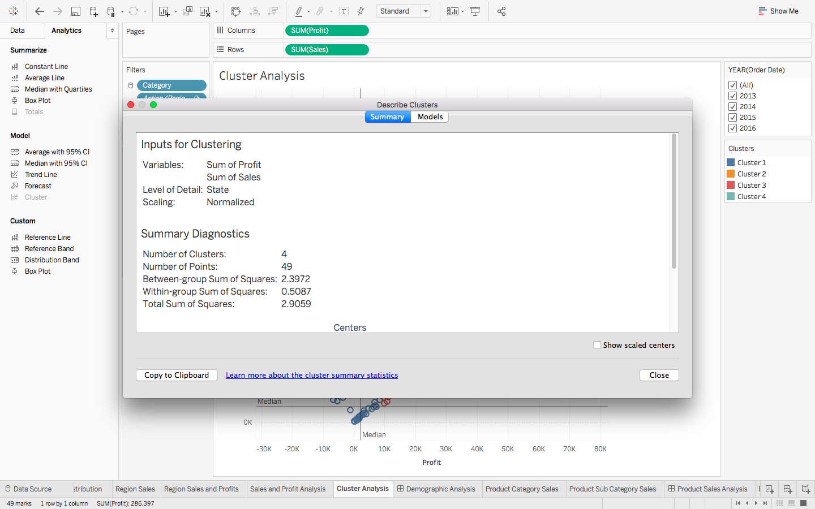

4. Dashboard

Dashboard is simply a means of combining Worksheets together so that they convey some message. Let’s get right to it!

Consider the **State Sales Distribution** Map chart and **Product Sub Categories.**

What if you wanted to know the various Sales margin of each Product within separate States? We had observed that Texas was one of the States with the lowest Profits. By looking at the following Dashboard, you will see that the reason is it’s not managing to generate Profits in majority of the Products:

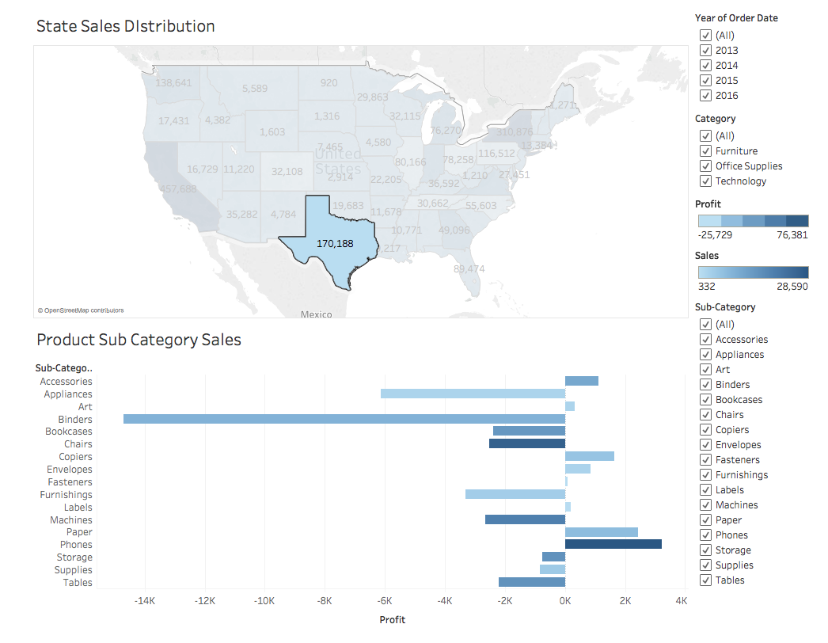

Now consider the state wise Sales distribution of a Sub – Category:

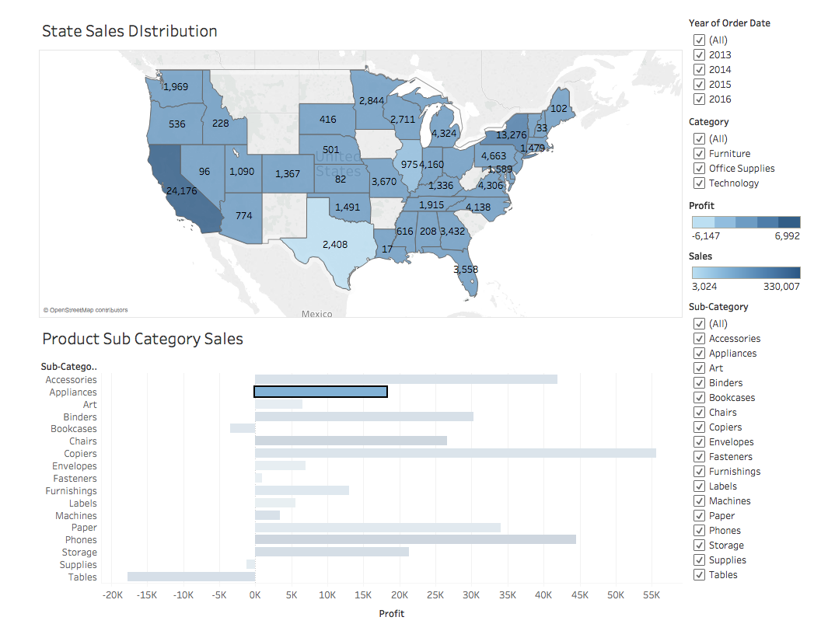

The above beautifully shows the distribution of **Appliances** over the country, where California seems to be the major Profit contributor.

Making such a Dashboard is actually quite easy. Let’s see how:

1. This time instead of creating a New Worksheet, we are going to create a new Dashboard. Click on the **window like icon** next to the ‘New Worksheet’ icon in the bottom pane to get the following:  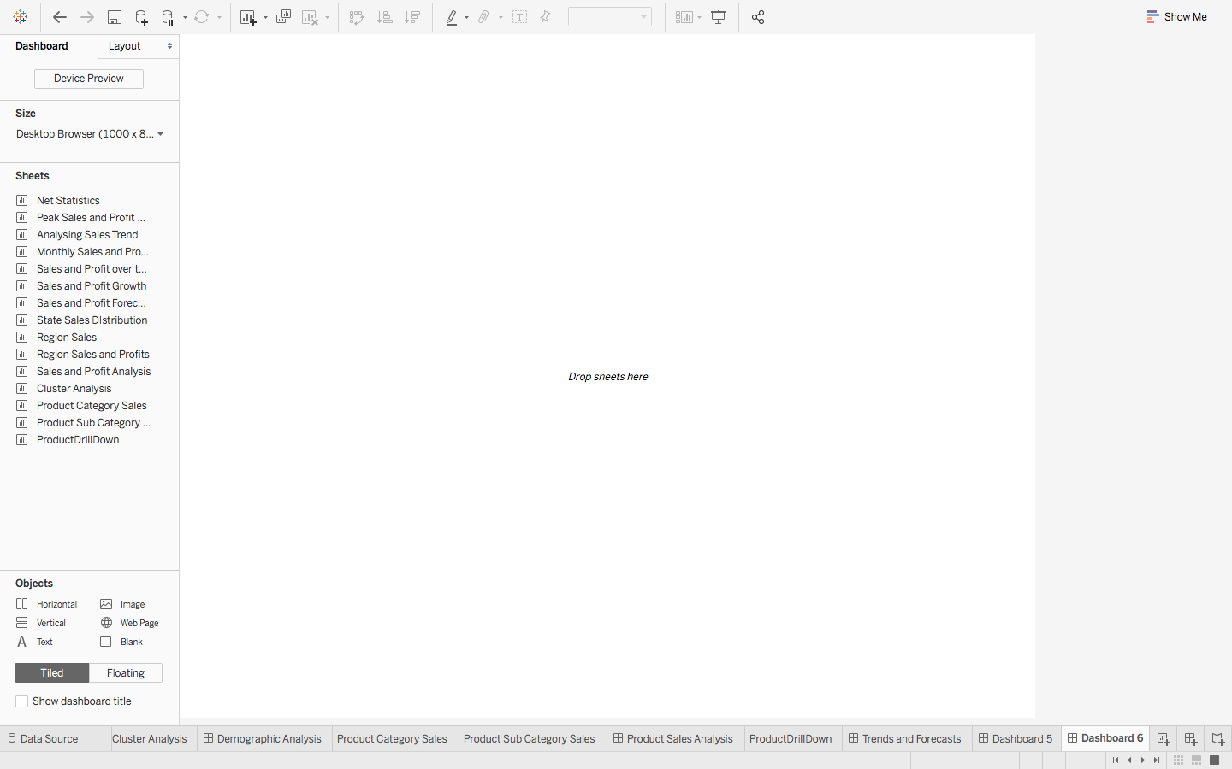
2. See the multiple Worksheets that we had made till now over on the left? All that we have to do to make a Dashboard is drag these sheets from the pane to the empty area ‘**Drop sheets here’.**
3. So, to make the previously displayed Dashboard, simply drag State Sales Distribution and Product Sub Category Sales. The Dashboard will automatically make space available for both of them.

**Note:** Even after the creation of the Dashboards, you can still edit your Worksheets, and the same changes shall be reflected here.

If you were to click on the States or the Products after creating your first ever Dashboard, you won’t observe any change. Because for such visuals, we first have to convert the Charts themselves into filters.

4. Simply click on the small Down Arrow on each chart you wish to turn into a Filter, and select **Use as Filter:**

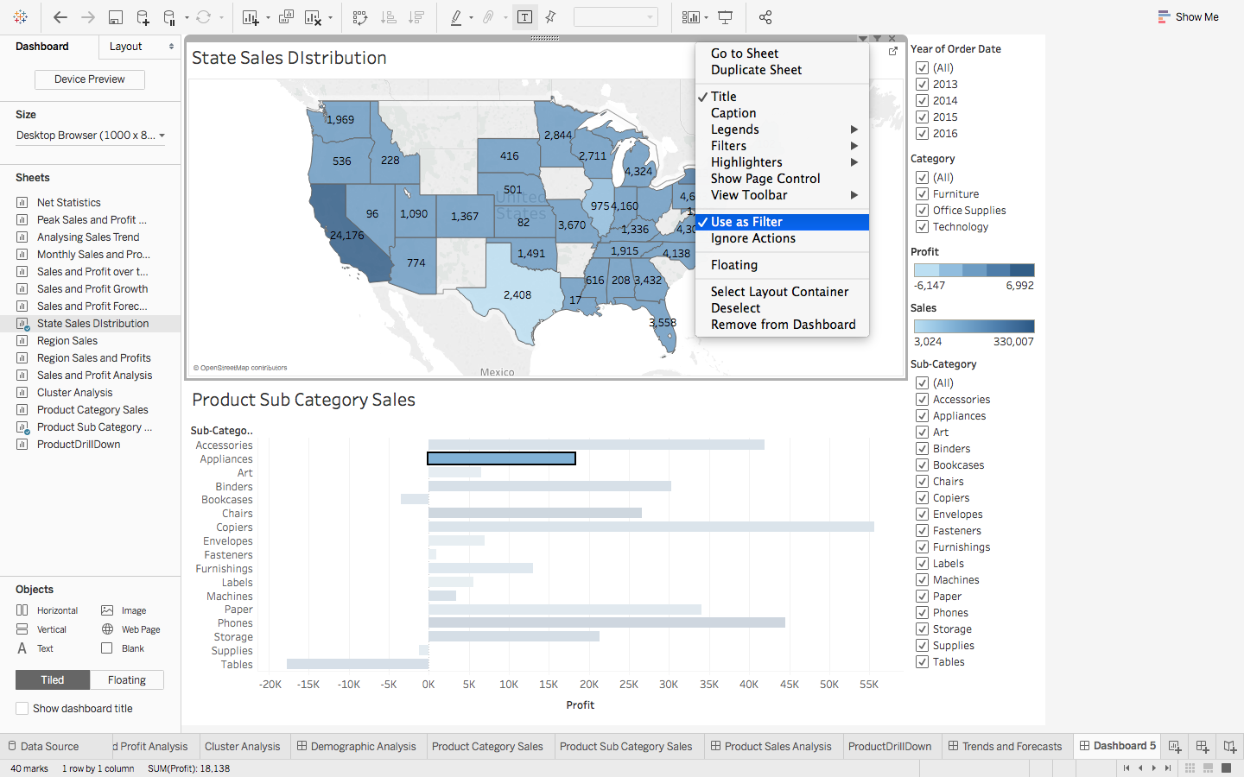

**Note:**While making Dashboards, it is preferred to **use your charts** as Filters, rather than cluttering up the view with custom ones.

5. Story – Bringing it all together

Just like Dashboards were a way to combine the Worksheets, a Story is where you combine all the dashboards, and if need be individual Sheets as well, to convey, as the name suggests – a Story.

1. Just like before, you simply drag your Worksheets and Dashboards onto the empty space:

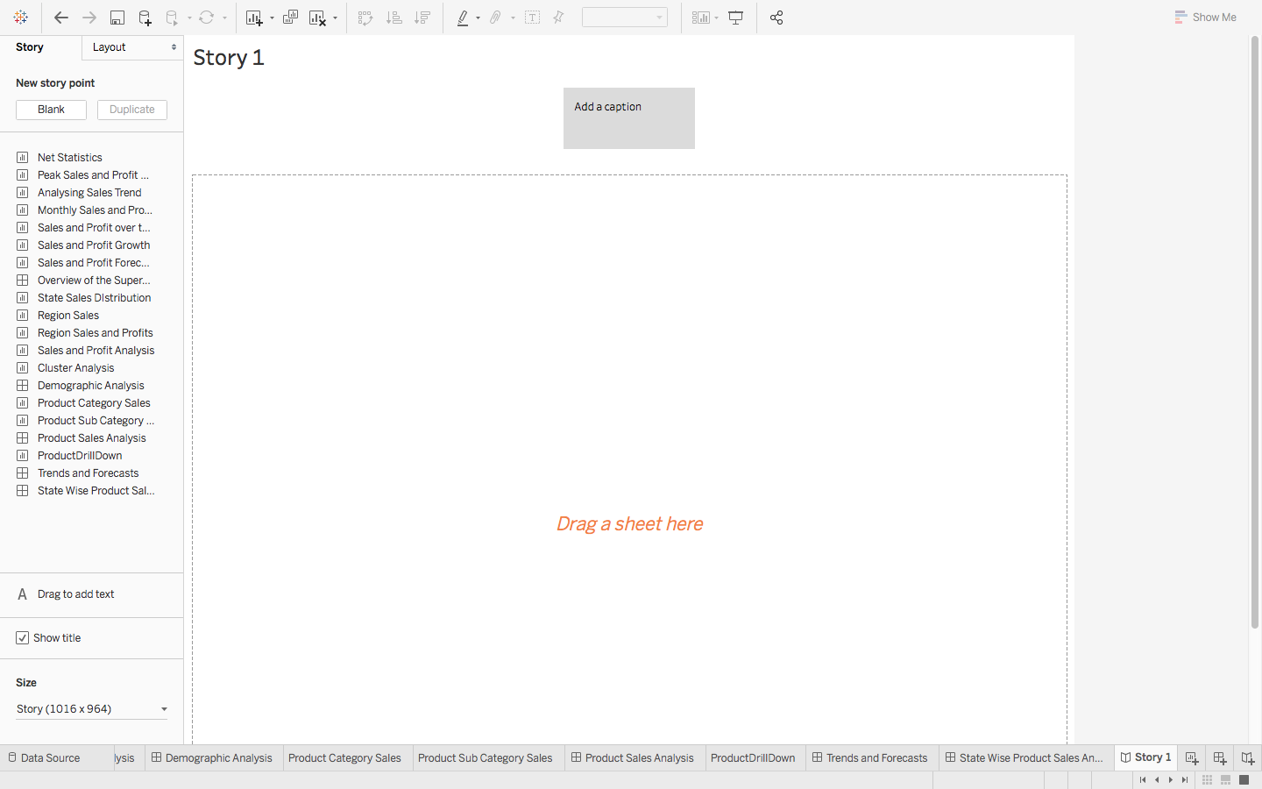

So, let’s combine all those Dashboards that we had made into what could perhaps make a decent presentation for a beginner. Do ensure to **Add a Caption** to all of your Dashboards, to convey your message clearly:

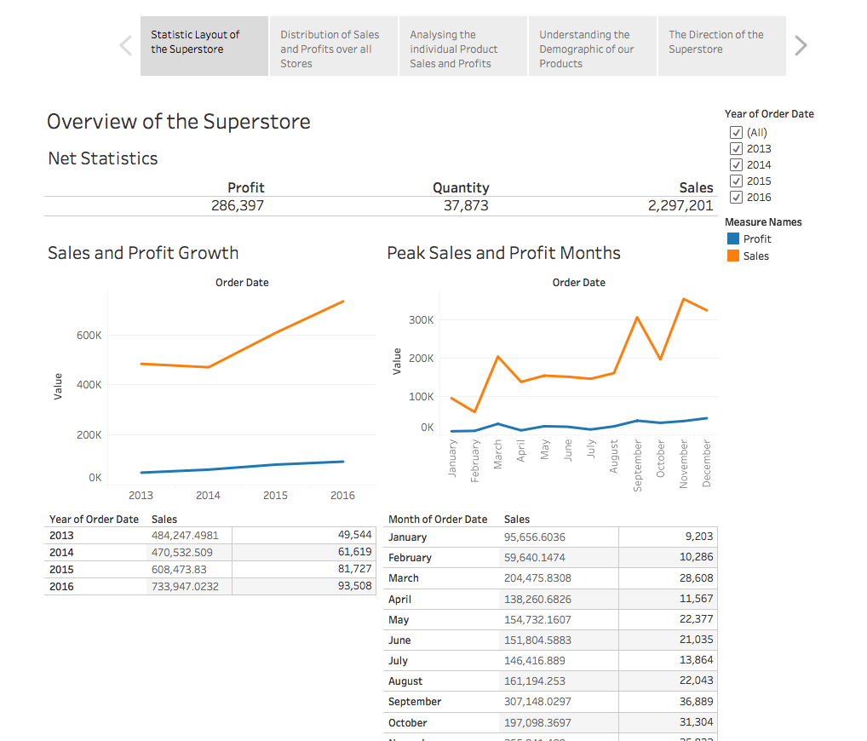

If you have ever come across Tableau Stories online, the ones which you could actually interact with, instead of just viewing, that is made possible by publishing your Workbooks onto the [Tableau Server](https://www.tableau.com/products/server).

If you have one set up, then all you need to do, after creating your Stories, is go to **Server -> Publish Workbook**and enter the Server Name:

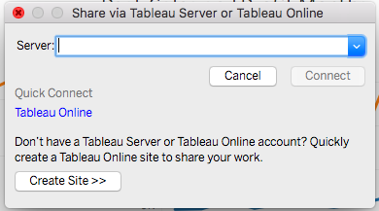

6. End Notes

What we have covered so far is pretty much the basics of Tableau. It has various other features.

Below is a sample Dashboard that I would encourage everyone of you to try and make. You will not only get to test the skills that you have learned so far, but also hopefully acquire more. The dataset used is the same as the one we had been working with so far:

